Position 1:
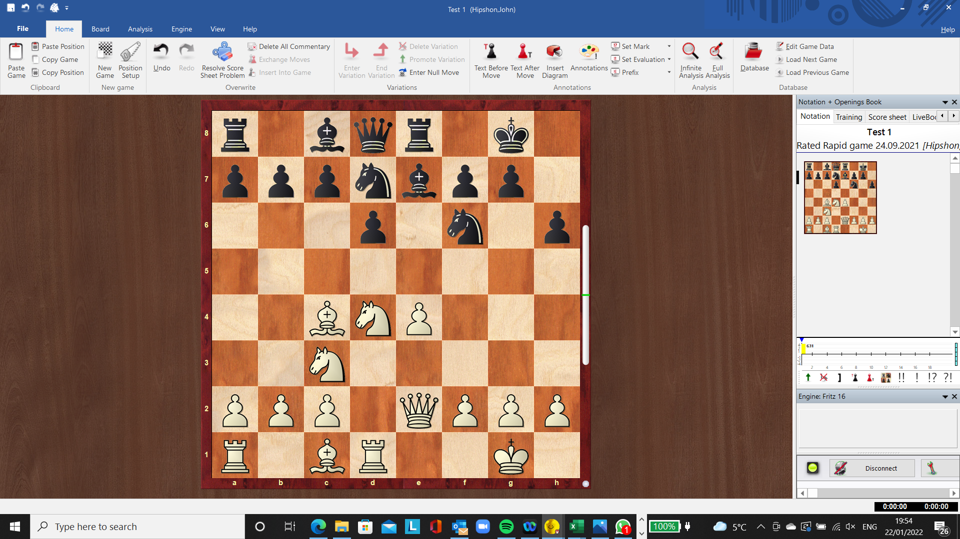

Which move would you play (white) and why?
- Ne6
- Bxf7+
- Bxh6
- Nf5
- Qf1

Position 2:
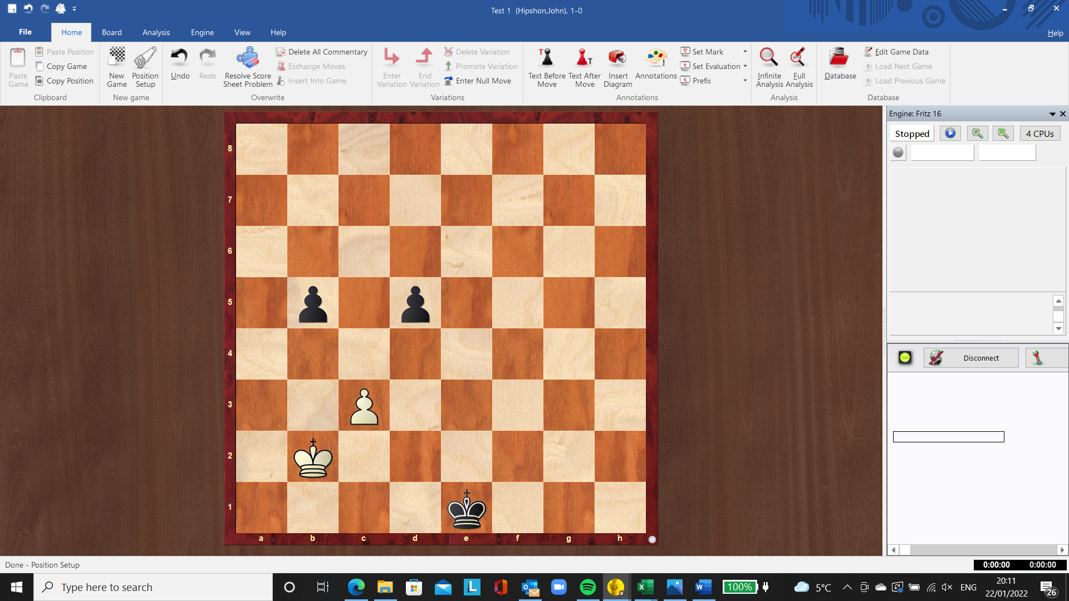
Which move would you play (white) and why?
- Kc1
- Ka1
- Anything but black will win anyway.
- Any dark square
- Any light square

Position3:
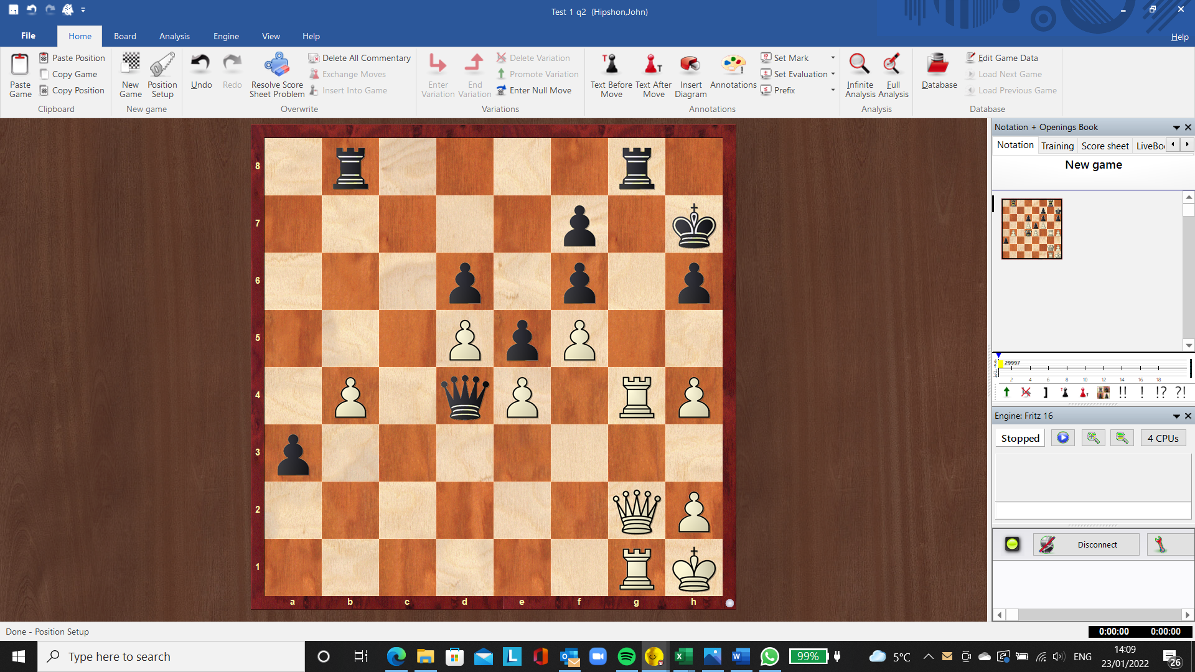
BLACK to play.
What is happening:
- The position looks like a possible draw.
- Black has to give up the queen to stop mate on the g file.
- Rgc8 will win for black.
- The passed a pawn favours a black win.
- Black can get a draw by perpetual check.

