NicTrapsLon 1-5 (Nick’s Traps London)
LJCC Group2 20231022
The first five of fifteen traps to be demonstrated to Group2 by Nick Nixon Autumn 2023
1 After 5 … Bb7, Wh 3-move combi wins pawn
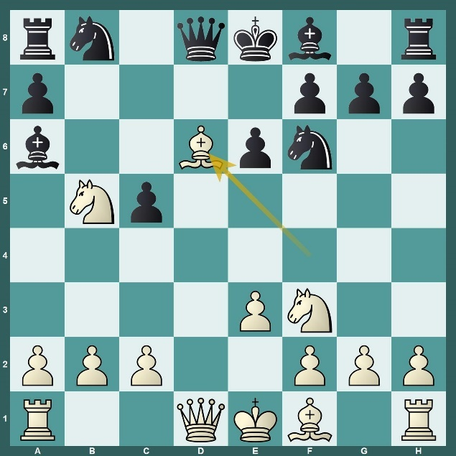

2 After 8. Ba6, Wh 3-move combi wins pawn
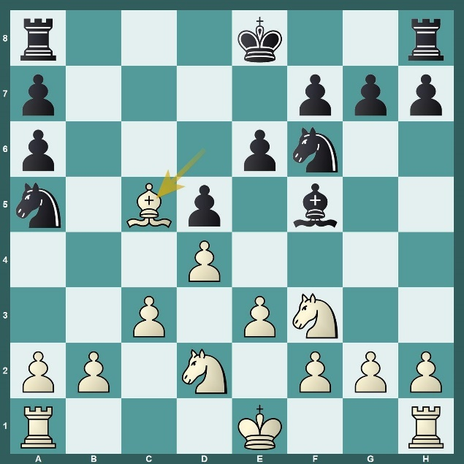
3 After 5 … cxd4, Wh 5-move combi wins N/Q
4 After 7 Ne5, Greek gift B sac clearly winning
5 After 6 dxc5, white’s B’s on long diags win
