An opening for black – the Caro-Kann Defence
For players who like to start the game with a stable position, as opposed to an immediate search for attack, The Caro-Kann is a reasonable choice of defence for black. Of course white has several different ways to play and black must be ready for all eventualities.

- White plays e5
Let’s follow a game which contains many of the normal ideas for black.
Sanchez Montesdeoca,I (1737) - Mueller,Mart2 (2038) [B12]
12th Montalvo Mem 2019 Las Palmas ESP (6.17), 17.04.2019

1.e2–e4 c7–c6 2.d2–d4 d7–d5 3.e4–e5

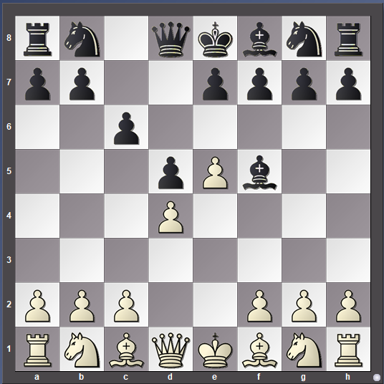
Black has played …d5 to establish a foothold in the centre. The move …c6 is played so that black can recapture on d5 with a pawn to maintain a pawn presence in the critical sector. When white advances with an immediate e5 black has the chance to develop the c8 bishop at once. An alternative is to wait for white to go nf3 and then play …Bg4. In both cases black can develop the bishop outside the pawn chain, play …e6 and be ready for …c5 challenging the white centre.
3…Bc8–f5 4.Ng1–f3 e7–e6 5.Bf1–e2 Ng8–e7 6.0–0 Bf5–g6 7.Nb1–d2 c6–c5 8.d4xc5 Ne7–c6
Both sides have started developing the forces and black has played the thematic…c5. There is no immediate rush for black to regain the pawn – it isn’t going anywhere. Development is more important. This process continues over the next few moves.
9.Nd2–b3 Nb8–d7 10.Bc1–e3 Qd8–c7 11.Be2–b5 a7–a6 12.Bb5–a4 Bf8–e7 13.h2–h4 0–0
(see next diagram)
From black’s point of view things have progressed fairly normally and he is now ready to recapture the pawn. White obviously felt that he should try to attack and played the slightly odd-looking h4. However, if it was intended to dissuade black from castling it did not work.

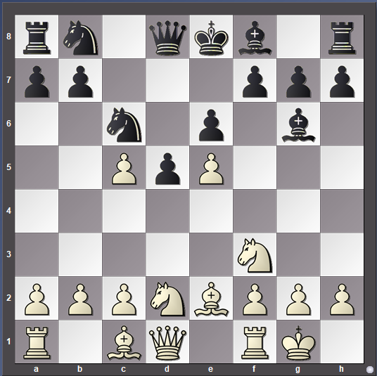

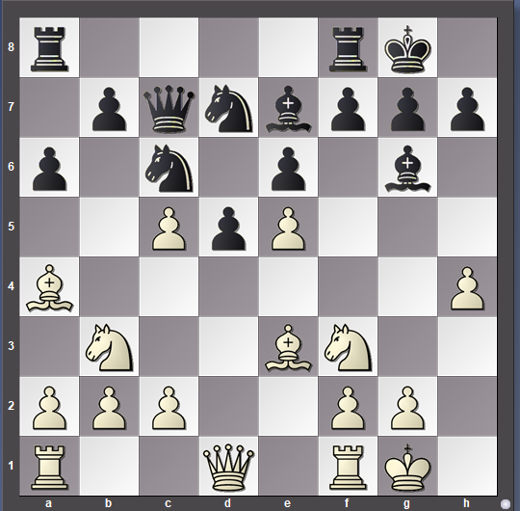
Black considers that he has plenty of defence around the king and the white attack seems to lack potency.
14.Nf3–g5 Qc7xe5 15.Ba4xc6 b7xc6 16.Nb3–d4 Ra8–c8 17.b2–b4 h7–h6 18.Ng5–f3 Qe5–b8 19.g2–g4
Black deliberately chose to take back the white e pawn so that he would be able to establish a huge pawn centre later with …e5 at some point.
White has had to operate on two fronts. On the queenside he has had to defend the c pawn, weakening his whole pawn position there in the process. On the kingside he has tried to find a way to increase the strength of the attack. The knight on d4 is well-placed but may well be chased away by …e5. A problem for white has been the loss of the white-squared bishop which usually has a big part to play in a kingside attack.
White’s last move (19.g4) is a huge risk trying to force through an attack. What follows is a clear demonstration of the power of a central counter-attack. Black completely destroys white’s centre and infiltrates his forces through the weakened queenside.
19…Qb8xb4 20.Ra1–b1 Qb4–a4 21.Rb1–b7 Rf8–d8 22.Qd1–a1 Be7xc5 23.Rb7xd7 Rd8xd7 In a last desperate attempt to keep the attack going white has sacrificed the exchange, but black remains clam and now calculates carefully to refute white’s play completely.
24.Nf3–e5 Bc5xd4 25.Be3xd4 Rd7–b7 26.c2–c4 Qa4–c2 27.h4–h5 Bg6–e4 28.Qa1–e1 Rb7–b1
Finally faced with a situation where he is the exchange and two pawns down and the major pieces are about to be exchanged white decided the time had come to call it a day and he resigned.

Black’s main ideas in the advance Caro-Kann are well displayed here: concentration of pressure on the centre, careful defence of the kingside and readiness to counter-attack when possible.

Here are some more games which will give you some ideas of how the play against white’s e5

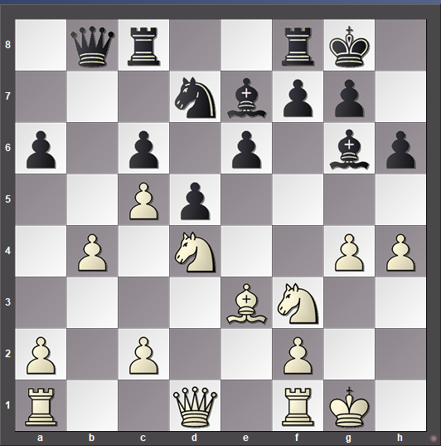

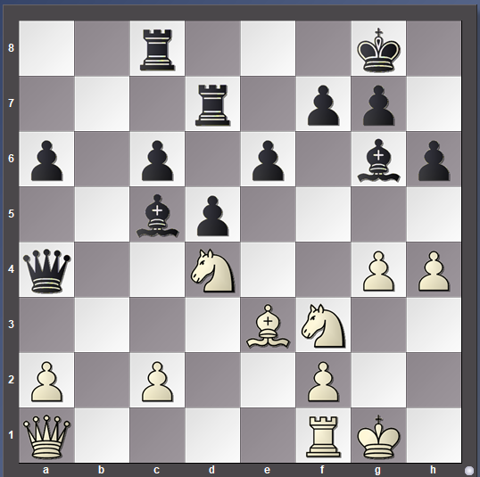

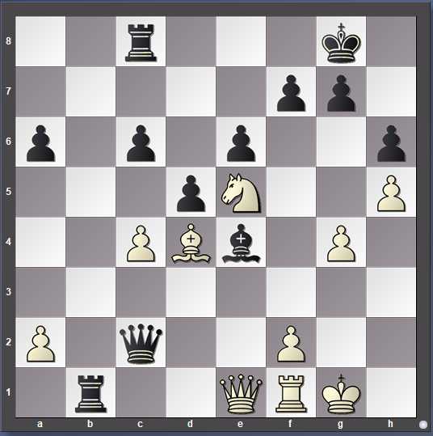
Griffith,Kyron (2349) - Shankland,S (2717) [B12]
Mechanics Institute Rapid San Francisco USA (5.7), 02.05.2019

1.e2–e4 c7–c6 2.d2–d4 d7–d5 3.e4–e5 Bc8–f5 4.h2–h4 h7–h5 5.c2–c4 e7–e6 6.Nb1–c3 Ng8–e7 7.Ng1–e2 Nb8–d7 8.Ne2–g3 Bf5–g6 9.c4xd5 Ne7xd5 10.Bf1–e2 Qd8–a5 11.Bc1–d2 0–0–0 12.0–0 Bf8–e7 13.Ng3–e4 Nd5xc3 14.Ne4xc3 Kc8–b8 15.Nc3–a4 Qa5–c7 16.b2–b4 Nd7–b6 17.Bd2–c3 Nb6–d5 18.Qd1–b3 Be7xh4 19.Na4–b2 Bh4–e7 20.a2–a4 Nd5xc3 21.Qb3xc3 Qc7–b6 22.b4–b5 Qb6xd4 23.Qc3xd4 Rd8xd4 24.b5xc6 Rd4–d2 0–1

Kraemer,St (2144) - Fridman,D (2629) [B12]
GRENKE Chess Open 2019 Karlsruhe GER (1.8), 18.04.2019

1.e2–e4 c7–c6 2.d2–d4 d7–d5 3.e4–e5 c6–c5 4.Ng1–f3 Bc8–g4 5.Bf1–e2 Nb8–c6 6.d4xc5 e7–e6 7.Nb1–d2 Bf8xc5 8.0–0 Ng8–e7 9.c2–c4 0–0 10.Qd1–a4 Bg4–h5 11.Qa4–b5 Bc5–b6 12.c4xd5 Qd8xd5 13.Qb5xd5 Ne7xd5 14.b2–b3 Nc6xe5 15.Nf3xe5 Bh5xe2 16.Rf1–e1 Bb6–d4 0–1

Zaloznik S.,Gal (1304) - Medic,N (1983) [B12]
49th Bosna Open 2019 Sarajevo BIH (6.42), 30.04.2019

1.e2–e4 c7–c6 2.d2–d4 d7–d5 3.e4–e5 c6–c5 4.c2–c3 Nb8–c6 5.Ng1–f3 Bc8–g4 6.g2–g3 c5xd4 7.c3xd4 Bg4xf3 8.Qd1xf3 Nc6xd4 9.Qf3–d3 Nd4–c6 10.Bf1–g2 e7–e6 11.f2–f4 Bf8–c5 12.Bc1–e3 Qd8–b6 13.Be3xc5 Qb6xc5 14.Nb1–c3 a7–a6 15.Ke1–e2 Nc6–b4 16.Qd3–d1 Qc5–c4+ 17.Ke2–e1 Nb4–d3+ 18.Ke1–e2 0–1

Khaetsky,R (2344) - Turov,M (2584) [B12]
7th Hofheim Spring Open Hofheim GER (8.2), 27.04.2019

1.e2–e4 c7–c6 2.d2–d4 d7–d5 3.e4–e5 Bc8–f5 4.c2–c4 e7–e6 5.Nb1–c3 Ng8–e7 6.a2–a3 Nb8–d7 7.c4–c5 f7–f6 8.f2–f4 b7–b6 9.b2–b4 a7–a5 10.Bc1–d2 g7–g6 11.Nc3–a4 a5xb4 12.a3xb4 b6xc5 13.b4xc5 Bf8–g7 14.Ng1–e2 Bf5–g4 15.Bd2–e3 Ne7–f5 16.Qd1–d3 f6xe5 17.d4xe5 Nd7xe5 18.Qd3–c3 Qd8–e7 19.Be3–f2 0–0 20.Ra1–a3 Ne5–c4 0–1

Ogando Herrera,Wander (1656) - Guzman Cabrera,Jose Francisco (1616) [B12]
ch-DOM 2019 Santo Domingo DOM (10.29), 11.05.2019

1.e2–e4 c7–c6 2.d2–d4 d7–d5 3.e4–e5 Bc8–f5 4.Ng1–f3 e7–e6 5.Bf1–e2 Nb8–d7 6.c2–c3 h7–h6 7.Nb1–d2 Qd8–b6 8.c3–c4 g7–g5 9.c4–c5 Qb6–c7 10.h2–h3 Bf8–g7 11.0–0 f7–f6 12.e5xf6 Ng8xf6 13.Nf3–h2 h6–h5 14.Rf1–e1 g5–g4 15.h3–h4 g4–g3 16.f2xg3 Qc7xg3 17.Nd2–f3 Nf6–g4 18.Bc1–g5 Nd7–f6 19.Qd1–b3 Nf6–e4 20.Bg5–e3 Ng4xe3 21.Qb3xe3 Bg7–h6 22.Qe3–b3 Qg3–f2+ 23.Kg1–h1 Ne4–g3# 0–1

Of course white does not have to play 3.e5, but you should be prepared to meet it.

- White exchanges pawns

When white exchanges pawns on d5 the centre becomes much more open with the result that the play frequently becomes more tactical. Black often castles on the queenside and launches a fierce attack against the white king castled on the opposite wing. Look at this game as an example:

Erenburg,S (2589) - Khamrakulov,D (2503) [B13]
PRO League Group Stage chess.com INT (2), 15.01.2019

1.e2–e4 c7–c6 2.d2–d4 d7–d5 3.e4xd5 c6xd5
The exchange of pawns has produced an open position where both sides can develop freely. In such situations you must make every move count by getting the pieces out as quickly and efficiently as possible in order to start creating threats. Good calculation skills are required!
4.Bf1–d3 Nb8–c6 5.c2–c3 Qd8–c7 6.Ng1–e2 Bc8–g4 7.0–0 e7–e6 8.Qd1–e1 Bf8–d6 9.Ne2–g3 Ng8–f6 10.f2–f4
So far both sides have got on with the job of getting pieces out. White’s last move is intended not only to blunt the action of black’s bishop on d6, but also to make a strongpoint on e5 and introduce the possibility of f5 to open up the e file at some point. However, the move also weakens whit’s kingside and black reacts by starting an attack against white’s king. In the coming moves black puts the king away on the queenside and tries to bring as many pieces as possible over to attack the white king.
10…h7–h5 11.h2–h3 h5–h4 12.Ng3–h1 Bg4–h5 13.Qe1xh4 0–0–0 14.Qh4–e1 g7–g5 15.f4xg5 Bd6–h2+ 16.Kg1–f2 Nf6–e4+ 17.Bd3xe4 d5xe4 18.Qe1xe4 Bh5–g6 19.Qe4–g4 Qc7–b6 20.Kf2–e1
Black has given up three pawns for a raging attack. White’s pieces are in total disarray. Black now found an attractive sacrifice which quickly finished white off:
20…Nc6xd4 21.c3xd4 Rd8xd4 22.Qg4–f3 Rd4–e4+ 23.Ke1–d1 Rh8–d8+ 24.Nb1–d2 Re4–e3 25.Qf3–f2 Qb6–c5 26.Qf2xe3 Qc5xe3 27.Nh1–f2 Bh2–f4

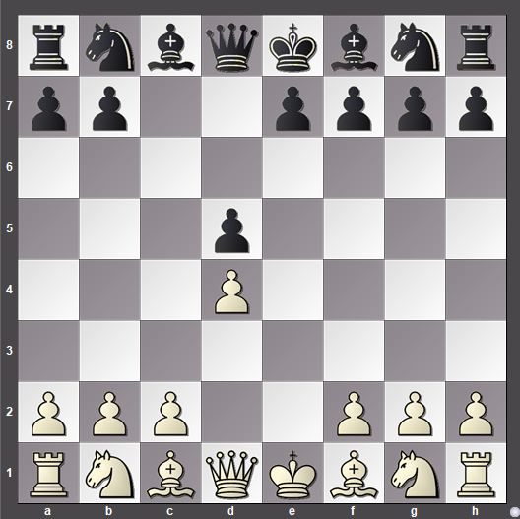

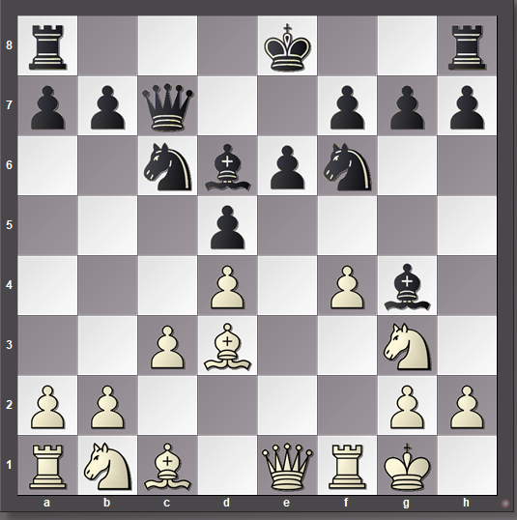
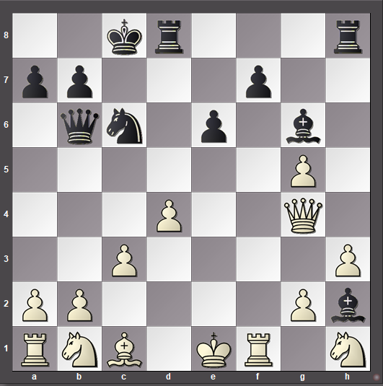
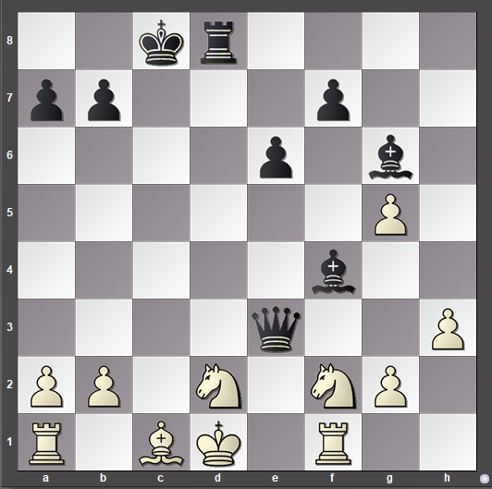
White resigned. …Rxd2 will lead to a quick checkmate.
This more open type of game is typical of the exchange variation. The play is much more tactical with both sides striving to land a knockout punch. Rapid development, aggressive ideas and good calculation are the order of the day.
There follow some games for you to study to see the sort of ideas that often crop up.

Van Foreest,Jorden (2612) - Anand,V (2773) [B13]
81st Tata Steel GpA Wijk aan Zee NED (1.5), 12.01.2019

1.e2–e4 c7–c6 2.d2–d4 d7–d5 3.e4xd5 c6xd5 4.Bf1–d3 Ng8–f6 5.c2–c3 Qd8–c7 6.h2–h3 g7–g6 7.Ng1–f3 Bc8–f5 8.Nf3–e5 Nb8–c6 9.Bc1–f4 Qc7–b6 10.Bd3xf5 g6xf5 11.Ne5–d3 e7–e6 12.Nb1–d2 Rh8–g8 13.0–0 0–0–0 14.a2–a4 Nf6–e4 15.Ra1–c1 Bf8–d6 16.Bf4xd6 Ne4xd6 17.b2–b4 Kc8–b8 18.Qd1–e2 Qb6–c7 19.Qe2–e3 Nc6–e7 20.f2–f3 Ne7–g6 21.Nd3–e5 f5–f4 22.Qe3–e1 Nd6–f5 23.Ne5xg6 Rg8xg6 24.Rf1–f2 Rd8–g8 25.c3–c4 Nf5–e3 26.c4xd5 Ne3xg2 27.Qe1–e5 Qc7xe5 28.d4xe5 Ng2–e1+ 0–1

Martinez Martin,D (2416) - Kadric,D (2545) [B13]
Gibraltar Masters 2019 Caleta ENG (6.48), 27.01.2019

1.e2–e4 c7–c6 2.d2–d4 d7–d5 3.e4xd5 c6xd5 4.Bf1–d3 Nb8–c6 5.c2–c3 Qd8–c7 6.Ng1–e2 Bc8–g4 7.0–0 Ng8–f6 8.Qd1–e1 e7–e6 9.Bc1–f4 Bf8–d6 10.Bf4xd6 Qc7xd6 11.Ne2–g3 0–0–0 12.f2–f3 Bg4–h5 13.Ng3xh5 Nf6xh5 14.Nb1–d2 Kc8–b8 15.b2–b4 Nh5–f4 16.Bd3–c2 e6–e5 17.b4–b5 e5xd4 18.b5xc6 Rh8–e8 19.Qe1–b1 Qd6xc6 20.Qb1–b4 Qc6–h6 21.Ra1–b1 b7–b6 22.Bc2–d1 d4xc3 23.Qb4xc3 Re8–e2 24.Rf1–f2 Re2xf2 25.Kg1xf2 Qh6–h4+ 26.Kf2–f1 Rd8–e8 27.Bd1–c2 Qh4xh2 28.Qc3xg7 Qh2–h1+ 0–1

Ceker,Cetin (1330) - Erdal,Kerem (1509) [B13]
Turkish Cup 2019 Antalya TUR (2.126), 28.01.2019

1.e2–e4 c7–c6 2.d2–d4 d7–d5 3.e4xd5 c6xd5 4.Bf1–d3 Ng8–f6 5.c2–c3 Nb8–c6 6.Ng1–f3 Bc8–g4 7.h2–h3 Bg4xf3 8.Qd1xf3 e7–e6 9.0–0 Qd8–c7 10.Bc1–f4 Bf8–d6 11.Bf4xd6 Qc7xd6 12.Nb1–a3 a7–a6 13.Rf1–e1 0–0 14.Na3–c2 Rf8–e8 15.Nc2–e3 Ra8–d8 16.Ne3–g4 Nf6xg4 17.Qf3xg4 e6–e5 18.Qg4–h4 e5–e4 19.Bd3–c2 Re8–e6 20.Re1–e3 Re6–h6 21.Qh4–g4 Rh6–g6 22.Qg4–e2 f7–f5 23.Qe2–h5 f5–f4 24.Re3–e1 f4–f3 25.g2–g4 Rg6–h6 26.Qh5xh6 Qd6xh6 27.Kg1–h2 Qh6–d2 0–1

Thorisson,Bjartur (1202) - Bjarnason,Larus H (1519) [B13]
Reykjavik Congress 2019 Reykjavik ISL (7.24), 27.01.2019

1.e2–e4 c7–c6 2.d2–d4 d7–d5 3.e4xd5 c6xd5 4.Bf1–d3 Nb8–c6 5.c2–c3 Ng8–f6 6.Ng1–e2 e7–e6 7.0–0 Bf8–d6 8.Bc1–g5 Qd8–c7 9.Qd1–c2 Bd6xh2+ 10.Kg1–h1 Bh2–d611.Bg5xf6 g7xf6 12.Bd3xh7 f6–f5 13.Nb1–d2 Rh8xh7+ 14.Kh1–g1 Bd6–h2+ 15.Kg1–h1 Bh2–g1 0–1
3. White defends e4

The third main way for white to play the opening is neither to advance with e5, exchange pawns with exd5 but to defend the e4 pawn with Nc3 or Nd2. Let’s follow a typical black victory:

Babikov,I (2268) - Koykka,P (2405) [B18]
48th Rilton Cup 2018–19 Stockholm SWE (6.36), 02.01.2019

1.e2–e4 c7–c6 2.d2–d4 d7–d5 3.Nb1–c3 d5xe4 4.Nc3xe4

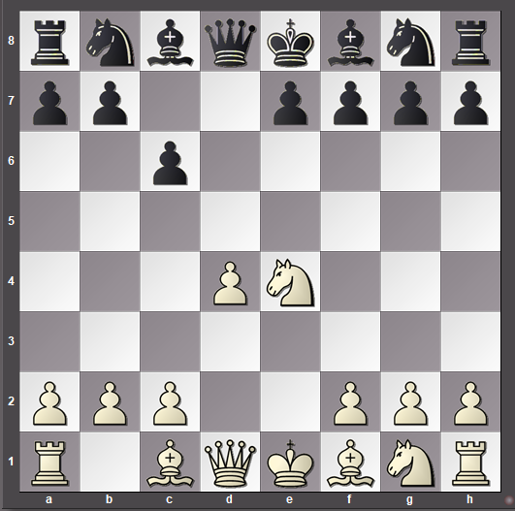
Again the centre pawns have been exchanged producing an open position where both sides can develop reasonably freely. However, the white pawn on d4 does give white a small space advantage and the fact that black’s e pawn has not yet moved gives white a small lead in development. In such circumstances black must be extra careful. On a positive note white’s knight allows black to develop with tempo.
4…Bc8–f5 5.Ne4–g3 Bf5–g6 6.Ng1–f3 e7–e6 7.h2–h4 h7–h6 8.Nf3–e5 Bg6–h7 9.c2–c3 Nb8–d7 10.Qd1–b3 Nd7xe5 11.d4xe5 Qd8–c7 12.Bc1–e3 Ng8–e7 13.0–0–0 Ne7–d5
Both sides have tried to develop actively. White’s knight has been driven offside to g3 and black has been careful to preserve the important white-squared bishop. The knight is impressively placed on d5 and chasing it away with c4 will weaken white’s queenside defences. The play is becoming more and more tactical. White’s next move is a retreat that give black the chance to build up his attack (14.Bd3 was much better)
14.Be3–d2 Bf8–c5 15.c3–c4 Bc5xf2 16.Qb3–f3 [not 16.c4xd5 c6xd5+ 17.Bd2–c3 Bf2–e3+ 18.Rd1–d2 d5–d4 and the game is all but over]
Just one slight mistake and the storm clouds are gathering over white’s king. Black has to sacrifice a piece but the white king is especially vulnerable. In particular the black bishop on h7 is enormously powerful.
16...Bf2–b6 17.c4xd5 c6xd5+ 18.Bd2–c3 0–0 19.Ng3–e2 f7–f6
See next diagram

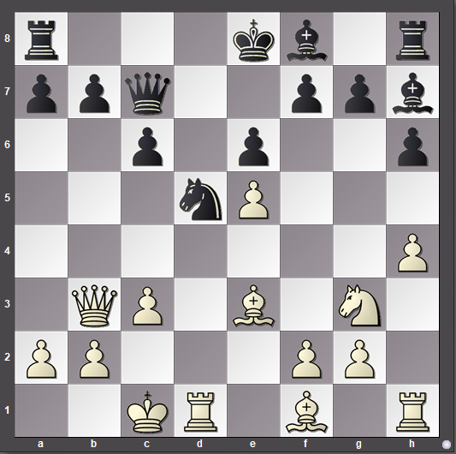

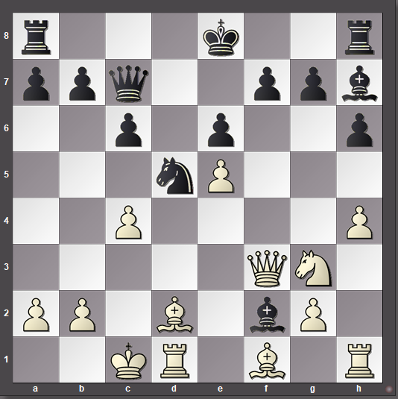

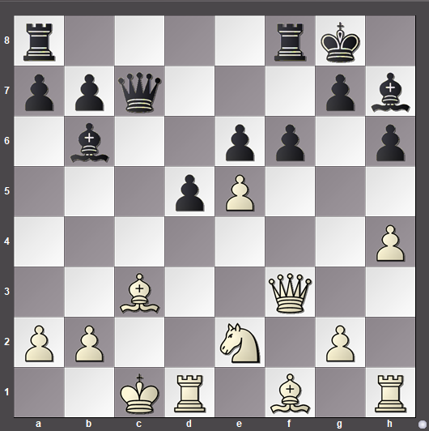
With typical attacking technique black adds another piece to his attack. The addition of the rook will stretch the white defences to breaking point.
20.e5xf6 Rf8xf6 21.Qf3–g3 Qc7–c4 22.Ne2–d4 Rf6xf1 23.Nd4xe6 Qc4-g4 24.Qg3xg4 Be3+ 25.Bc3-d2 Ra8-c8+ 26,Ne6-c7 Rc8Xc7#
One slight error enabled black to outplay white completely. Here are some more games for you to study:

Nielsen,Andre (2260) - Andersen,AlfR (2256) [B15]
TCh-NOR Elite 2018–19 Norway NOR (5.2), 12.01.2019

1.e2–e4 c7–c6 2.d2–d4 d7–d5 3.Nb1–c3 d5xe4 4.Nc3xe4 Ng8–f6 5.Ne4xf6+ e7xf6 6.Bf1–c4 Bf8–d6 7.Qd1–e2+ Bd6–e7 8.Ng1–f3 0–0 9.0–0 Be7–d6 10.Rf1–e1 Nb8–a6 11.Nf3–h4 Na6–c7 12.Qe2–h5 Bc8–e6 13.Bc4–d3 g7–g6 14.Qh5–f3 f6–f5 15.g2–g3 Bd6–e7 16.Bc1–f4 Be6–d5 17.Qf3–e3 Be7xh4 18.g3xh4 Rf8–e8 19.Qe3–g3 Nc7–e6 20.c2–c4 Bd5–e4 21.Bd3xe4 f5xe4 22.Re1xe4 Ne6xd4 23.Re4xe8+ Qd8xe8 24.Qg3–e3 Qe8–d7 25.Ra1–f1 Ra8–e8 26.Qe3–a3 Nd4–e2+ 0–1

Chibnall,Alana (1944) - Gong,Daniel Hanwen (2247) [B18]
126th ch-NZL Open 2019 Auckland NZL (2.8), 15.01.2019

1.e2–e4 c7–c6 2.d2–d4 d7–d5 3.Nb1–c3 d5xe4 4.Nc3xe4 Bc8–f5 5.Ne4–g3 Bf5–g6 6.Ng1–f3 e7–e6 7.h2–h4 h7–h6 8.h4–h5 Bg6–h7 9.Bf1–d3 Bh7xd3 10.Qd1xd3 Ng8–f6 11.Bc1–d2 Bf8–e7 12.0–0–0 0–0 13.Qd3–e2 b7–b5 14.Nf3–e5 Qd8–d5 15.Kc1–b1 Nb8–d7 16.f2–f4 Rf8–e8 17.Rh1–e1 Be7–f8 18.Ng3–h1 c6–c5 19.g2–g4 c5xd4 20.g4–g5 h6xg5 21.Ne5xd7 Nf6xd7 22.f4xg5 Qd5–c4 23.Qe2–f2 Ra8–c8 24.Bd2–c1 e6–e5 25.Nh1–g3 Re8–e6 26.Ng3–e4 Re6–c6 27.Re1–e2 d4–d3 0–1

Agrest,I (2275) - Vachier Lagrave,M (2780) [B15]
PRO League Group Stage chess.com INT (2), 17.01.2019

1.e2–e4 c7–c6 2.d2–d4 d7–d5 3.Nb1–c3 d5xe4 4.Nc3xe4 Ng8–f6 5.Ne4xf6+ e7xf6 6.Qd1–d3 Bf8–d6 7.Bc1–e3 Qd8–a5+ 8.Be3–d2 Qa5–c7 9.Ng1–f3 0–0 10.0–0–0 Bc8–e6 11.Kc1–b1 Nb8–d7 12.Qd3–e4 Rf8–e8 13.Qe4–h4 Nd7–f8 14.Bf1–d3 Nf8–g6 15.Qh4–h5 c6–c5 16.d4–d5 Be6–d7 17.g2–g4 b7–b5 18.Rh1–g1 c5–c4 19.Bd3–f5 b5–b4 20.c2–c3 Ra8–b8 21.Nf3–d4 Bd6–e5 22.Bf5xd7 Qc7xd7 23.Nd4–c6 b4xc3 24.Nc6xb8 Re8xb8 25.Bd2–c1 Rb8xb2+ 26.Bc1xb2 Qd7–b5 0–1

Rosado Perez,M (1801) - Franco Valencia,B (2147) [B17]
Zonal 2.3 Women 2019 Cartagena COL (9.3), 20.07.2019

1.e2–e4 c7–c6 2.d2–d4 d7–d5 3.Nb1–c3 d5xe4 4.Nc3xe4 Nb8–d7 5.Ng1–f3 g7–g6 6.a2–a3 Bf8–g7 7.Bc1–f4 Qd8–a5+ 8.c2–c3 Qa5–f5 9.Qd1–e2 Qf5xf4 10.g2–g3 Qf4–c7 0–1
Of course there are many other ways for white to play. White may not even play 2.d4. Here are a few games to demonstrate that black can do well against any white treatment of the opening. The common theme is that black concentrates on trying to gain control of the central squares and maintain vigilance for the tactical opportunities that arise.

Diaz Hernandez,H (2353) - Narciso Dublan,M (2489) [B10]
Platja d'Aro Open 2019 Platja d'Aro ESP (8.7), 30.06.2019

1.e2–e4 c7–c6 2.Nb1–c3 d7–d5 3.Ng1–f3 Ng8–f6 4.Qd1–e2 Bc8–g4 5.h2–h3 Bg4xf3 6.Qe2xf3 e7–e6 7.e4xd5 c6xd5 8.Bf1–b5+ Nb8–c6 9.0–0 Bf8–e7 10.d2–d4 Qd8–b6 11.Bb5xc6+ Qb6xc6 12.Qf3–g3 0–0 13.Bc1–h6 Nf6–e8 14.Rf1–c1 Qc6–b6 15.Nc3–e2 Qb6xb2 16.Ra1–b1 Qb2–a3 17.Rb1–b3 Qa3–a6 18.Ne2–f4 Be7–d6 19.Qg3–g4 f7–f5 20.Qg4–h4 g7xh6 21.Rb3–g3+ Ne8–g7 22.Rg3xg7+ Kg8xg7 23.Nf4xe6+ Kg7–h8 24.Qh4xh6 Rf8–f7 25.Ne6–g5 Rf7–g7 0–1

Van Foreest,Jorden (2601) - Wei Yi (2736) [B10]
chess.com Junior Speed chess.com INT (2.26), 10.07.2019

1.e2–e4 c7–c6 2.Ng1–f3 d7–d5 3.Nb1–c3 Ng8–f6 4.e4–e5 Nf6–e4 5.d2–d4 Ne4xc3 6.b2xc3 c6–c5 7.d4xc5 Nb8–c6 8.Bf1–d3 Bc8–g4 9.h2–h3 Bg4xf3 10.Qd1xf3 e7–e6 11.Bc1–f4 Bf8xc5 12.0–0 0–0 13.Rf1–e1 Qd8–h4 14.Ra1–b1 b7–b6 15.c3–c4 Nc6–d4 16.Qf3–g4 Qh4xg4 17.h3xg4 d5xc4 18.Bd3–e4 Ra8–c8 19.Re1–d1 Nd4–e2+ 0–1

Kosteniuk,A (2546) - Gunina,V (2506) [B11]
chess.com Women's Speed chess.com INT (2.27), 23.06.2019

1.e2–e4 c7–c6 2.Ng1–f3 d7–d5 3.Nb1–c3 Bc8–g4 4.Bf1–e2 Bg4xf3 5.Be2xf3 e7–e6 6.d2–d4 Ng8–f6 7.e4–e5 Nf6–d7 8.0–0 Bf8–e7 9.Bf3–e2 c6–c5 10.d4xc5 Nb8–c6 11.f2–f4 Nd7xc5 12.Kg1–h1 0–0 13.Nc3–b5 Nc5–e4 14.c2–c3 Qd8–b6 15.Nb5–d4 Nc6xd4 16.c3xd4 Ra8–c8 17.Be2–f3 Rc8–c4 18.Bf3xe4 d5xe4 19.Bc1–e3 Qb6xb2 20.Ra1–b1 Qb2xa2 21.Rb1xb7 Be7–b4 22.f4–f5 e6xf5 23.d4–d5 a7–a5 24.d5–d6 Rc4–c3 25.Be3–g5 Rc3–d3 26.Qd1–c1 Qa2–d5 27.Rb7–c7 Qd5xe5 28.Bg5–e7 Bb4xd6 29.Be7xf8 Bd6xc70–1

Gunina,V (2515) - Charochkina,D (2333) [B10]
9th Blondes vs. Brunettes Moscow RUS (6.4), 16.03.2019

1.e2–e4 c7–c6 2.Nb1–c3 d7–d5 3.Ng1–f3 Ng8–f6 4.e4–e5 Nf6–e4 5.Nc3–e2 Qd8–b6 6.d2–d4 e7–e6 7.c2–c3 c6–c5 8.g2–g3 Nb8–c6 9.Bf1–g2 c5xd4 10.Ne2xd4 Bf8–c5 11.0–0 0–0 12.Qd1–d3 Bc8–d7 13.a2–a4 Bc5xd4 14.Nf3xd4 Nc6xe5 15.Qd3–e2 Ne5–g6 16.h2–h4 e6–e5 17.Nd4–c2 Ne4xg3 18.Qe2–d3 Ng3xf1 19.Bg2xf1 Ng6xh4 20.Nc2–e3 Nh4–f3+ 21.Kg1–h1 Qb6–h6+ 0–1

Learning how to play any new opening is difficult. Your success will depend on how much work you are prepared to do. Studying games by good players is a great way to start. Constant practice is important too/ Above all you must play well! Once you have some ideas try them out and see what works and learn from your mistakes.

